import numpy as np
v=np.arange(-100,101,1)
print(v)

OUTPUT
[-100 -99 -98 -97 -96 -95 -94 -93 -92 -91 -90 -89 -88 -87
-86 -85 -84 -83 -82 -81 -80 -79 -78 -77 -76 -75 -74 -73
-72 -71 -70 -69 -68 -67 -66 -65 -64 -63 -62 -61 -60 -59
-58 -57 -56 -55 -54 -53 -52 -51 -50 -49 -48 -47 -46 -45
-44 -43 -42 -41 -40 -39 -38 -37 -36 -35 -34 -33 -32 -31
-30 -29 -28 -27 -26 -25 -24 -23 -22 -21 -20 -19 -18 -17
-16 -15 -14 -13 -12 -11 -10 -9 -8 -7 -6 -5 -4 -3
-2 -1 0 1 2 3 4 5 6 7 8 9 10 11
12 13 14 15 16 17 18 19 20 21 22 23 24 25
26 27 28 29 30 31 32 33 34 35 36 37 38 39
40 41 42 43 44 45 46 47 48 49 50 51 52 53
54 55 56 57 58 59 60 61 62 63 64 65 66 67
68 69 70 71 72 73 74 75 76 77 78 79 80 81
82 83 84 85 86 87 88 89 90 91 92 93 94 95
96 97 98 99 100]

vneg=v[0:101:1]
vpos=v[100::]
print("neg",vneg)
print("pos",vpos)

OUTPUT
neg [-100 -99 -98 -97 -96 -95 -94 -93 -92 -91 -90 -89 -88 -87
-86 -85 -84 -83 -82 -81 -80 -79 -78 -77 -76 -75 -74 -73
-72 -71 -70 -69 -68 -67 -66 -65 -64 -63 -62 -61 -60 -59
-58 -57 -56 -55 -54 -53 -52 -51 -50 -49 -48 -47 -46 -45
-44 -43 -42 -41 -40 -39 -38 -37 -36 -35 -34 -33 -32 -31
-30 -29 -28 -27 -26 -25 -24 -23 -22 -21 -20 -19 -18 -17
-16 -15 -14 -13 -12 -11 -10 -9 -8 -7 -6 -5 -4 -3
-2 -1 0]
pos [ 0 1 2 3 4 5 6 7 8 9 10 11 12 13 14 15 16 17
18 19 20 21 22 23 24 25 26 27 28 29 30 31 32 33 34 35
36 37 38 39 40 41 42 43 44 45 46 47 48 49 50 51 52 53
54 55 56 57 58 59 60 61 62 63 64 65 66 67 68 69 70 71
72 73 74 75 76 77 78 79 80 81 82 83 84 85 86 87 88 89
90 91 92 93 94 95 96 97 98 99 100]

vneg1=v[v<=0]
vpos1=v[v>=0]
print("neg1",vneg1)
print("pos1",vpos1)

OUTPUT
neg1 [-100 -99 -98 -97 -96 -95 -94 -93 -92 -91 -90 -89 -88 -87
-86 -85 -84 -83 -82 -81 -80 -79 -78 -77 -76 -75 -74 -73
-72 -71 -70 -69 -68 -67 -66 -65 -64 -63 -62 -61 -60 -59
-58 -57 -56 -55 -54 -53 -52 -51 -50 -49 -48 -47 -46 -45
-44 -43 -42 -41 -40 -39 -38 -37 -36 -35 -34 -33 -32 -31
-30 -29 -28 -27 -26 -25 -24 -23 -22 -21 -20 -19 -18 -17
-16 -15 -14 -13 -12 -11 -10 -9 -8 -7 -6 -5 -4 -3
-2 -1 0]
pos1 [ 0 1 2 3 4 5 6 7 8 9 10 11 12 13 14 15 16 17
18 19 20 21 22 23 24 25 26 27 28 29 30 31 32 33 34 35
36 37 38 39 40 41 42 43 44 45 46 47 48 49 50 51 52 53
54 55 56 57 58 59 60 61 62 63 64 65 66 67 68 69 70 71
72 73 74 75 76 77 78 79 80 81 82 83 84 85 86 87 88 89
90 91 92 93 94 95 96 97 98 99 100]

import numpy as np
Amp=5; P=10; PA=P/100; f=P**-1
tempo=np.arange(0,P+PA,PA)
funcao=Amp*np.sin(2*np.pi*f*tempo)
from matplotlib import pyplot as plt
plt.plot(tempo,funcao)
plt.grid()
plt.show()

OUTPUT

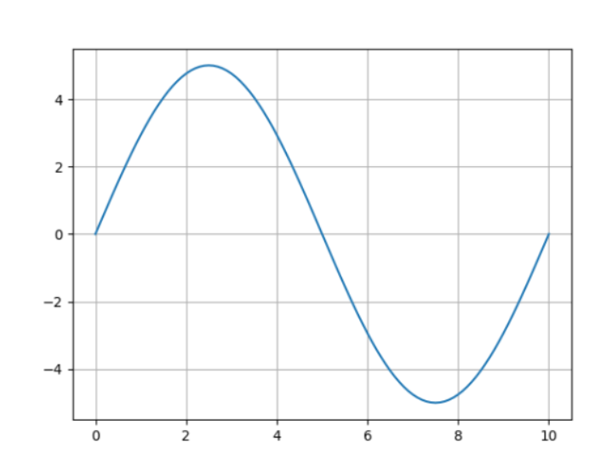

import numpy as np
A=np.array([[1,2],
[3,4]])
print(A)

OUTPUT

[[1 2]
[3 4]]

import numpy as np
A=np.array([[1,2,3,4],
[5,6,7,8],
[9,10,11,12],
[13,14,15,16]])
print(A)

B=A[0:2,0:2]
print("\n sup esq \n",B)

C=A[2:,2:]
print("\n inf dir \n",C)

OUTPUT
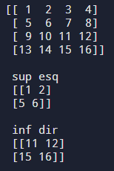

import numpy as np
A=np.array([[5,3,4],
[6,-10,21],
[-7,12,14]])
b=np.array([50,-5,-10])
sol=np.linalg.solve(A,b)
x=sol[0]; y=sol[1]; z=sol[2]
print("x = ",x)
print("y = ",y)
print("z = ",z)

print(5*x+3*y+4*z, '=', 50)
print(6*x-10*y+21*z, '=', -5)
print(-7*x+12*y+14*z, '=', -10)

OUTPUT
